# 开发记录-鱼眼柱面矫正检测模型

# 1. 数据分析

## 1.1 数据量：

Total：

* 82905张图片+json标签

Categary：

* Person：48145

* Car：265640

* Cyclist：30870

图示：

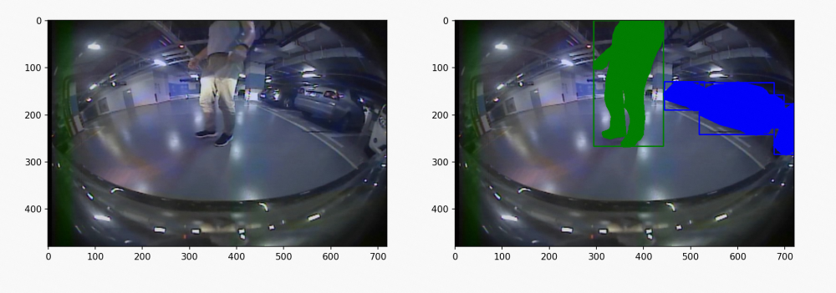

## 1.2 场景：

地下停车场+地上街道

## 1.3 标签：

检测框 + Mask + Person Car Cyclist类别

# 2. 标签处理

## 2.1 目的：

目的：能检测鱼眼与AR摄像头中的Person、Car、Cyclist

## 2.2 鱼眼矫正方法：

棋盘格矫正/横向展开/经纬度矫正：<https://aliyuque.antfin.com/uwk7mr/lvhh2l/dqefcmp5dd17nxu2>

圆柱矫正：<https://aliyuque.antfin.com/uwk7mr/lvhh2l/qpp6eqrqx6rgix76?singleDoc#>

注：根据任务需求，采用圆柱矫正，优点是可以将Person Car Cyclist类别矫正至相对直立的状态

## 2.3 鱼眼矫正效果：

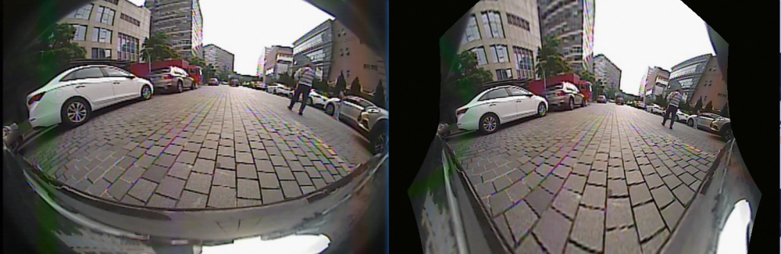

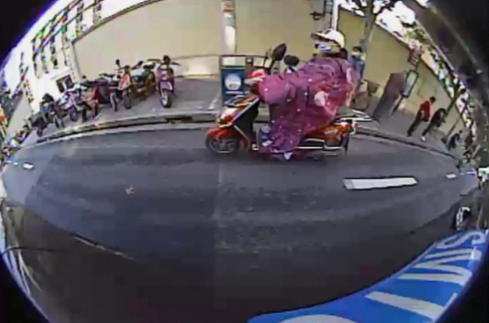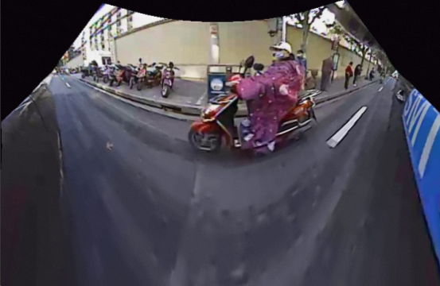

## 2.4 创建新数据集：

* Total data 10WAR tevs multi task model

* mini data 鱼眼3W

* mini data 圆柱矫正后的鱼眼3W

* mini data 3W鱼眼+3WAR

* mini data 3W矫正鱼眼+3WAR

* mini data 3W矫正鱼眼+3W鱼眼 + 3WAR

* Total data 8W矫正鱼眼+8W张鱼眼 + 10WAR

* 测试集：AR val + 鱼眼 val + AR 定性 + 鱼眼定性

# 3. 模型训练

## 3.1 训练20230428：

### - 训练参数：

|  |  |  |
| --- | --- | --- |
| 数据地址 | 本地3090： | 鱼眼数据：/workspace/dataset/project_datasets/360FisheyeDadaSet/360FisheyeDadaSet/origin  矫正后的的鱼眼数据：/workspace/dataset/project_datasets/360FisheyeDadaSet/360FisheyeDadaSet/origin_correct |
|  | 集群docker： | 矫正后的的鱼眼数据：/workspace/workdir/tevs_multi_idc_10g_20220825163730/dwt/datasets/360FisheyeDadaSet/origin_correct |
| 分辨率 | InputSize | 96x320 |
| 模型 | 结构 | NanoDetPlus |
| BackBone | name: LCNet  scale: 0.25  feature_maps: [ 3, 4, 5 ]  activation: ReLU |
| FPN | name: GhostPANMini  in_channels: [32, 64, 128]  out_channels: 96  kernel_size: 3  num_extra_level: 0  use_depthwise: True  activation: ReLU  expand: 1  num_blocks: 1  upsample_cfg: {scale_factor: 2, mode: "bilinear"}  use_res: False |
| Head | name: NanoDetPlusHead  num_classes: 3  input_channel: 96  feat_channels: 96  stacked_convs: 1  kernel_size: 3  strides: [8, 32]  activation: ReLU  reg_max: 7  norm_cfg:  type: BN  loss:  loss_qfl:  name: QualityFocalLoss  use_sigmoid: True  beta: 2.0  loss_weight: 1.0  loss_dfl:  name: DistributionFocalLoss  loss_weight: 0.25  loss_bbox:  name: GIoULoss  loss_weight: 2.0 |
| AuxHead | name: SimpleConvHead  num_classes: 3  input_channel: 192  feat_channels: 192  stacked_convs: 2  strides: [8, 32]  activation: ReLU  reg_max: 7 |
| 数据增强 | RandomPaddingCropDet | resizes: [96, 480]  cropsizes: [96, 96]  whratio: 3.33  prob: 1  mode: 'short'  keep_ratio: true  allow_no_crop: true  thresholds: [.01, .1, .3, .5, .7, .9]  num_attempts: 50 |
|  | RandomFlip | type='RandomFlip'  prob=0.5 |
|  | RandomDistort |  |
| 优化器 | 优化器 | AdamW |
|  | 学习率 | 0.01 |
|  | weight_decay | 0.0004 |
|  | batchsize | 128 |
|  | lr_schedule | CosineAnnealingLR |
|  | epoch | 300epoch |
| 数据 |  | 1. Total data 10WAR tevs multi task model  1. mini data 鱼眼3W  1. mini data 圆柱矫正后的鱼眼3W  1. mini data 3W鱼眼+3WAR  1. mini data 3W矫正鱼眼+3WAR  1. mini data 3W矫正鱼眼+3W鱼眼 + 3WAR  1. Total data 8W矫正鱼眼+8W张鱼眼 + 10WAR |

### - 定量对比：

|  |  |  |  |  |  |  |  |
| --- | --- | --- | --- | --- | --- | --- | --- |
| 数据 | AR mini val（4068） | AR total val（10377） | fish total val（3396） | correct fish total val（3396） | 本地3090模型地址 | 本地3090数据地址 | docker数据地址 |
| 1. Total data 10WAR tevs multi task model | - | pedestrian：5.2(AP50)|2.0(mAP)  rider：19.5(AP50)|8.5(mAP)  vehical：42.4(AP50)|23.9(mAP)  **total：0.224(AP50)** | - | pedestrian：0.5(AP50)|0.2(mAP)  rider：1.5(AP50)|0.3(mAP)  vehical：3.0(AP50)|0.7(mAP)  **total：0.017(AP50)** | /home/zhouziqin/workdir/torch_TevsTrain/2st_add/sgd_0.25_0.5_300e_paddleaug/TevsTrain/workspace/multi-nanodet-fastscnn_320_96_s_stride8_multitask_adam_lr0.16_mini_size3_300_det_add_025_05_relu_2head | seg：  seglane_dataset_root: /workspace/dataset/project_datasets/BanmaSegV2  seglane_path: /workspace/dataset/project_datasets/BanmaSegV2/train_multihead_dataset_list.txt  seglane_path: /workspace/dataset/project_datasets/BanmaSegV2/val_multihead_dataset_list.txt  det：  img_path: /workspace/dataset/project_datasets/multi_det_crop/target_new_crop/images  other_img_path: [/home/dangwanting/datasets/caoji_person_rider]  ann_path: /home/dangwanting/datasets/caoji_person_rider/train.json  ann_path: /home/dangwanting/datasets/caoji_person_rider/val.json | seg：  seglane_dataset_root: /workspace/workdir/tevs_multi_idc_10g_20220825163730/multi_seg/BanmaSegV2  seglane_path: /workspace/workdir/tevs_multi_idc_10g_20220825163730/multi_seg/BanmaSegV2/train_multihead_dataset_list.txt  seglane_path: /workspace/workdir/tevs_multi_idc_10g_20220825163730/multi_seg/BanmaSegV2/val_multihead_dataset_list.txt  det：  img_path: /workspace/workdir/tevs_multi_idc_10g_20220825163730/multi_det/target_new_crop/images  ann_path: /workspace/workdir/tevs_multi_idc_10g_20220825163730/multi_train/0203data/train.json  ann_path: /workspace/workdir/tevs_multi_idc_10g_20220825163730/multi_train/0203data/val.json |
| 1. mini data 鱼眼3W | - | - | pedestrian：29.4(AP50)|14.4(mAP)  rider：26.3(AP50)|11.7(mAP)  vehical：54.3(AP50)|29.7(mAP)  **total：0.367(AP50)** | - | /home/zhouziqin/workdir/torch_TevsTrain/2st_add/sgd_0.25_0.5_300e_paddleaug/TevsTrain/workspace/multi-nanodet-fastscnn_320_96_s_stride8_multitask_adam_lr0.16_mini_size3_300_det_add_025_05_relu_2head_3fish | img_path: /workspace/dataset/project_datasets/360FisheyeDadaSet/360FisheyeDadaSet/origin  ann_path: /workspace/dataset/project_datasets/360FisheyeDadaSet/360FisheyeDadaSet/origin/360FisheyeDadaSet3w_train.json  ann_path: /workspace/dataset/project_datasets/360FisheyeDadaSet/360FisheyeDadaSet/origin/360FisheyeDadaSet8w_val.json | img_path：/workspace/workdir/tevs_multi_idc_10g_20220825163730/dwt/datasets/360FisheyeDadaSet/origin  ann_path：/workspace/workdir/tevs_multi_idc_10g_20220825163730/dwt/datasets/360FisheyeDadaSet/origin/360FisheyeDadaSet3w_train.json  ann_path：/workspace/workdir/tevs_multi_idc_10g_20220825163730/dwt/datasets/360FisheyeDadaSet/origin/360FisheyeDadaSet8w_val.json |
| 1. mini data 圆柱矫正后的鱼眼3W | - | - | - | pedestrian：31.2(AP50)|14.5(mAP)  rider：24.8(AP50)|11.4(mAP)  vehical：54.0(AP50)|27.5(mAP)  **total：0.367(AP50)** | /home/zhouziqin/workdir/torch_TevsTrain/2st_add/sgd_0.25_0.5_300e_paddleaug/TevsTrain/workspace/multi-nanodet-fastscnn_320_96_s_stride8_multitask_adam_lr0.16_mini_size3_300_det_add_025_05_relu_2head_3fish_correct | img_path: /workspace/dataset/project_datasets/360FisheyeDadaSet/360FisheyeDadaSet/origin_correct  ann_path: /workspace/dataset/project_datasets/360FisheyeDadaSet/360FisheyeDadaSet/origin_correct/360FisheyeDadaSet3w_train.json  ann_path: /workspace/dataset/project_datasets/360FisheyeDadaSet/360FisheyeDadaSet/origin_correct/360FisheyeDadaSet8w_val.json | img_path：/workspace/workdir/tevs_multi_idc_10g_20220825163730/dwt/datasets/360FisheyeDadaSet/origin_correct  ann_path：/workspace/workdir/tevs_multi_idc_10g_20220825163730/dwt/datasets/360FisheyeDadaSet/origin_correct/360FisheyeDadaSet3w_train.json  ann_path：/workspace/workdir/tevs_multi_idc_10g_20220825163730/dwt/datasets/360FisheyeDadaSet/origin_correct/360FisheyeDadaSet8w_val.json |
| 1. mini data 3W鱼眼+3WAR | pedestrian：2.5(AP50)|0.7(mAP)  rider：13.5(AP50)|6.0(mAP)  vehical：47.9(AP50)|28.0(mAP)  **total：0.213(AP50)** | - | pedestrian：26.2(AP50)|12.3(mAP)  rider：22.0(AP50)|9.2(mAP)  vehical：51.0(AP50)|26.6(mAP)  **total：0.331(AP50)** | - | /home/zhouziqin/workdir/torch_TevsTrain/2st_add/sgd_0.25_0.5_300e_paddleaug/TevsTrain/workspace/multi-nanodet-fastscnn_320_96_s_stride8_multitask_adam_lr0.16_mini_size3_300_det_add_025_05_relu_2head_3fish3AR | img_path: /workspace/dataset/project_datasets/360FisheyeDadaSet/360FisheyeDadaSet/origin  other_img_path: [/workspace/dataset/project_datasets/multi_det_crop/target_crop/images]  ann_path: /workspace/dataset/project_datasets/360FisheyeDadaSet/360FisheyeDadaSet/origin/360FisheyeDadaSet3w_AR3w_train.json  ann_path: /workspace/dataset/project_datasets/360FisheyeDadaSet/360FisheyeDadaSet/origin/360FisheyeDadaSet8w_AR3w_val.json | img_path：/workspace/workdir/tevs_multi_idc_10g_20220825163730/dwt/datasets/360FisheyeDadaSet/origin  other_img_path: [/workspace/workdir/tevs_multi_idc_10g_20220825163730/target_crop/images]  ann_path：/workspace/workdir/tevs_multi_idc_10g_20220825163730/dwt/datasets/360FisheyeDadaSet/origin/360FisheyeDadaSet3w_AR3w_train.json  ann_path：/workspace/workdir/tevs_multi_idc_10g_20220825163730/dwt/datasets/360FisheyeDadaSet/origin/360FisheyeDadaSet8w_AR3w_val.json |
| 1. mini data 3W矫正鱼眼+3WAR | pedestrian：3.3(AP50)|1.1(mAP)  rider：14.4(AP50)|6.3(mAP)  vehical：49.3(AP50)|28.8(mAP)  **total：0.223(AP50)** | - | - | pedestrian：28.6(AP50)|12.5(mAP)  rider：19.5(AP50)|8.9(mAP)  vehical：49.3(AP50)|24.3(mAP)  **total：0.325(AP50)** | /home/zhouziqin/workdir/torch_TevsTrain/2st_add/sgd_0.25_0.5_300e_paddleaug/TevsTrain/workspace/multi-nanodet-fastscnn_320_96_s_stride8_multitask_adam_lr0.16_mini_size3_300_det_add_025_05_relu_2head_3fish_correct_3AR | img_path: /workspace/dataset/project_datasets/360FisheyeDadaSet/360FisheyeDadaSet/origin_correct  other_img_path: [/workspace/dataset/project_datasets/multi_det_crop/target_crop/images]  ann_path: /workspace/dataset/project_datasets/360FisheyeDadaSet/360FisheyeDadaSet/origin_correct/360FisheyeDadaSet3w_AR3w_train.json  ann_path: /workspace/dataset/project_datasets/360FisheyeDadaSet/360FisheyeDadaSet/origin_correct/360FisheyeDadaSet8w_AR3w_val.json | img_path：/workspace/workdir/tevs_multi_idc_10g_20220825163730/dwt/datasets/360FisheyeDadaSet/origin_correct  other_img_path: [/workspace/workdir/tevs_multi_idc_10g_20220825163730/target_crop/images]  ann_path：/workspace/workdir/tevs_multi_idc_10g_20220825163730/dwt/datasets/360FisheyeDadaSet/origin_correct/360FisheyeDadaSet3w_AR3w_train.json  ann_path：/workspace/workdir/tevs_multi_idc_10g_20220825163730/dwt/datasets/360FisheyeDadaSet/origin_correct/360FisheyeDadaSet8w_AR3w_val.json |
| 1. mini data 3W矫正鱼眼+3W鱼眼 + 3WAR | pedestrian：2.0(AP50)|0.6(mAP)  rider：13.3(AP50)|6.0(mAP)  vehical：47.0(AP50)|27.3(mAP)  **total：0.208(AP50)** | - | pedestrian：26.3(AP50)|11.9(mAP)  rider：24.7(AP50)|10.6(mAP)  vehical：53.3(AP50)|28.4(mAP)  **total：0.348(AP50)** | pedestrian：28.1(AP50)|12.5(mAP)  rider：21.6(AP50)|10.0(mAP)  vehical：48.5(AP50)|23.8(mAP)  **total：0.327(AP50)** | /home/zhouziqin/workdir/torch_TevsTrain/2st_add/sgd_0.25_0.5_300e_paddleaug/TevsTrain/workspace/multi-nanodet-fastscnn_320_96_s_stride8_multitask_adam_lr0.16_mini_size3_300_det_add_025_05_relu_2head_3fish_3fishcorrect_3AR | img_path: /workspace/dataset/project_datasets/360FisheyeDadaSet/360FisheyeDadaSet  other_img_path: [/workspace/dataset/project_datasets/multi_det_crop/target_new_crop/images, /home/dangwanting/datasets/caoji_person_rider]  ann_path: /workspace/dataset/project_datasets/360FisheyeDadaSet/360FisheyeDadaSet/origin_correct/360FisheyeDadaSet3w_correct3W_AR3w_train.json  ann_path: /workspace/dataset/project_datasets/360FisheyeDadaSet/360FisheyeDadaSet/origin_correct/360FisheyeDadaSet8w_correct8W_AR3w_val.json | img_path：/workspace/workdir/tevs_multi_idc_10g_20220825163730/dwt/datasets/360FisheyeDadaSet  other_img_path: [/workspace/workdir/tevs_multi_idc_10g_20220825163730/target_crop/images]  ann_path：/workspace/workdir/tevs_multi_idc_10g_20220825163730/dwt/datasets/origin_correct/360FisheyeDadaSet/360FisheyeDadaSet3w_correct3W_AR3w_train.json  ann_path：/workspace/workdir/tevs_multi_idc_10g_20220825163730/dwt/datasets/origin_correct/360FisheyeDadaSet/360FisheyeDadaSet8w_correct8W_AR3w_val.json |
| 1. Total data 8W矫正鱼眼+8W张鱼眼 + 10WAR | - | pedestrian：4.6(AP50)|1.9(mAP)  rider：17.0(AP50)|7.5(mAP)  vehical：41.1(AP50)|23.0(mAP)  **total：0.209(AP50)** | pedestrian：25.6(AP50)|11.0(mAP)  rider：23.2(AP50)|9.6(mAP)  vehical：51.5(AP50)|26.8(mAP)  **total：0.334(AP50)** | pedestrian：26.8(AP50)|11.6(mAP)  rider：20.9(AP50)|9.2(mAP)  vehical：47.9(AP50)|23.3(mAP)  **total：0.318(AP50)** | /home/zhouziqin/workdir/torch_TevsTrain/2st_add/sgd_0.25_0.5_300e_paddleaug/TevsTrain/workspace/multi-nanodet-fastscnn_320_96_s_stride8_multitask_adam_lr0.16_mini_size3_300_det_add_025_05_relu_2head_8fish_8fishcorrect_8AR_banmaseg | seg：  seglane_dataset_root: /workspace/dataset/project_datasets/BanmaSegV2  seglane_path: /workspace/dataset/project_datasets/BanmaSegV2/train_multihead_dataset_list.txt  seglane_path: /workspace/dataset/project_datasets/BanmaSegV2/val_multihead_dataset_list.txt  det：  img_path: /workspace/dataset/project_datasets/360FisheyeDadaSet/360FisheyeDadaSet  other_img_path: [/workspace/dataset/project_datasets/multi_det_crop/target_new_crop/images, /home/dangwanting/datasets/caoji_person_rider]  ann_path: /workspace/dataset/project_datasets/360FisheyeDadaSet/360FisheyeDadaSet/origin_correct/360FisheyeDadaSet8w_correct8W_AR8w_train.json  ann_path: /workspace/dataset/project_datasets/360FisheyeDadaSet/360FisheyeDadaSet/origin_correct/360FisheyeDadaSet8w_correct8W_AR8w_val.json | seg：  seglane_dataset_root: /workspace/workdir/tevs_multi_idc_10g_20220825163730/multi_seg/BanmaSegV2  seglane_path: /workspace/workdir/tevs_multi_idc_10g_20220825163730/multi_seg/BanmaSegV2/train_multihead_dataset_list.txt  det：  img_path：/workspace/workdir/tevs_multi_idc_10g_20220825163730/dwt/datasets/360FisheyeDadaSet  other_img_path：[/workspace/workdir/tevs_multi_idc_10g_20220825163730/multi_det/target_new_crop/images]  ann_path：/workspace/workdir/tevs_multi_idc_10g_20220825163730/dwt/datasets/360FisheyeDadaSet/origin_correct/360FisheyeDadaSet8w_correct8W_AR8w_train.json  ann_path：/workspace/workdir/tevs_multi_idc_10g_20220825163730/dwt/datasets/360FisheyeDadaSet/origin_correct/360FisheyeDadaSet8w_correct8W_AR8w_val.json |

**实验总结：**

* **在鱼眼验证集上**，mini data 鱼眼3W(实验2)与mini data 圆柱矫正后的鱼眼3W(实验3)的效果最好，为mAP50均为**0.367，未矫正时分别高出**mini data 3W鱼眼+3WAR(实验4)、mini data 3W矫正鱼眼+3W鱼眼 + 3WAR(实验6)的定量指标为：**3.6%、1.9%**，**矫正时分别高出**mini data 3W矫正鱼眼+3WAR(实验5)、mini data 3W矫正鱼眼+3W鱼眼 + 3WAR(实验6)的定量指标为：**4.5%、4%**

(注：val数据一样，区别只是是否增加圆柱矫正前处理)

* **在AR mini验证集上**，mini data 3W鱼眼+3WAR(实验4)、mini data 3W矫正鱼眼+3WAR(实验5)、mini data 3W矫正鱼眼+3W鱼眼 + 3WAR(实验6)中，实验5的效果最好，mAP50为**0.223**

* **在鱼眼+AR mini验证集上**，mini data 3W鱼眼+3WAR(实验4)、mini data 3W矫正鱼眼+3WAR(实验5)、mini data 3W矫正鱼眼+3W鱼眼 + 3WAR(实验6)中，实验6的效果最好。

**实验分析：**

1. 将鱼眼训练数据多样化能提高模型的泛化能力，使其同时适应AR场景、鱼眼场景、圆柱矫正后的鱼眼场景，但也会降低其在单一场景的精度。

1. 训练数据的复杂程度与单一场景精度的下降速率是非线性变化的。随着训练数据的复杂化，单一场景的精度下降速率变缓，如：实验6的与实验4、5相比，AR场景的精度下降较少，鱼眼场景的精度略有上升。

**实验结论：**

1. **只需适应单一场景的业务：使用单AR/鱼眼数据训练的模型。（AR：实验1/鱼眼：实验3）**

1. **需要适应多场景的业务：使用最多样化的数据集训练的模型。（实验7）**

### - 鱼眼定性对比(合肥)：

* mini data 鱼眼3W(实验2)：

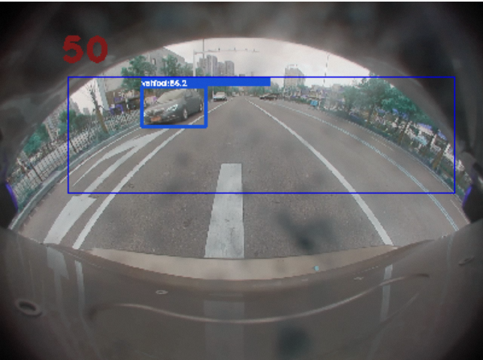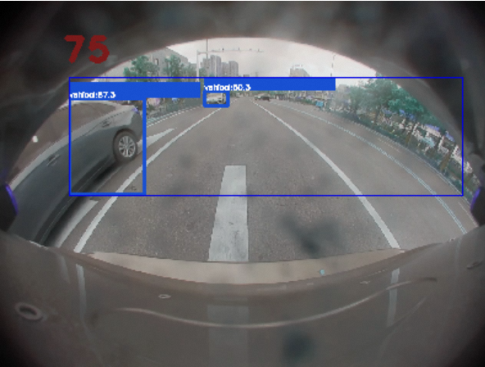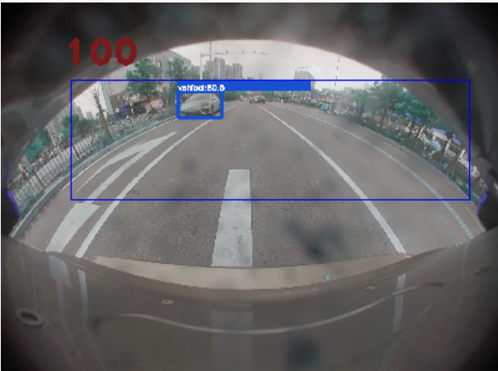

* mini data 3W鱼眼+3WAR(实验4)：

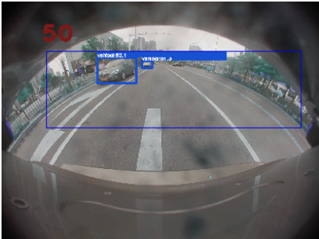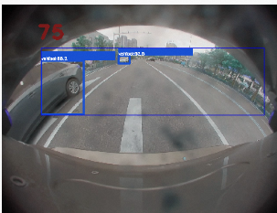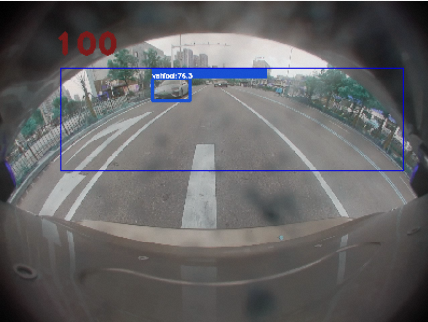

* Total data 10WAR tevs multi task model(实验1)：

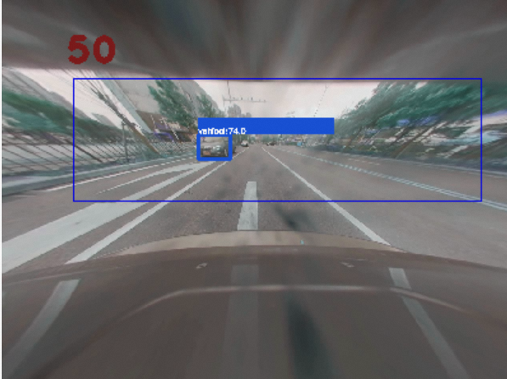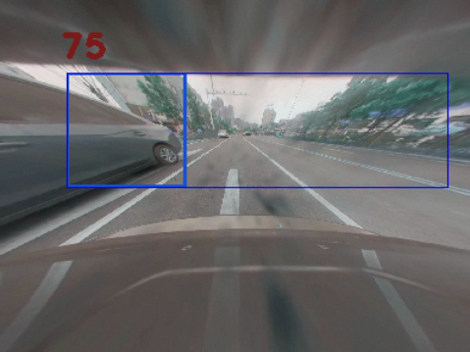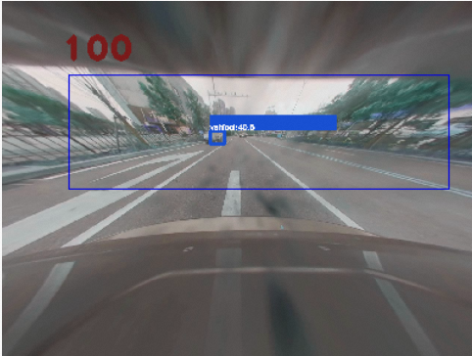

* mini data 圆柱矫正后的鱼眼3W(实验3)：

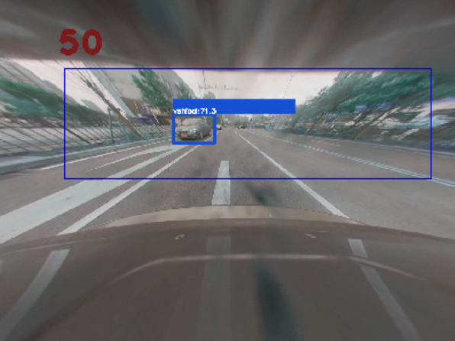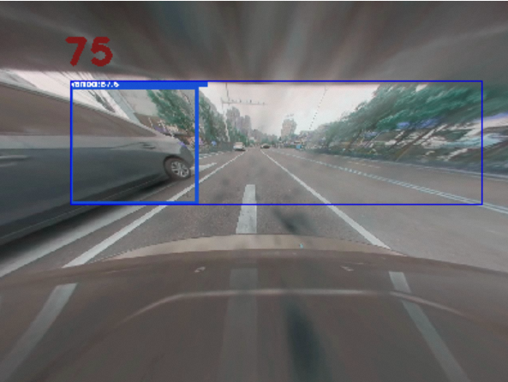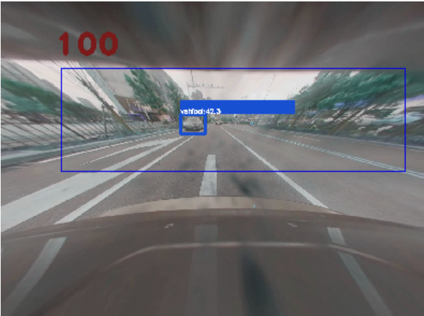

* mini data 3W矫正鱼眼+3WAR(实验5)：

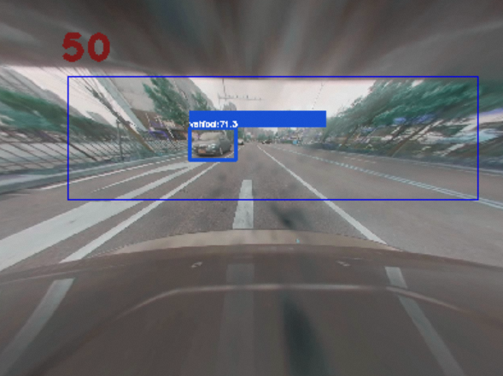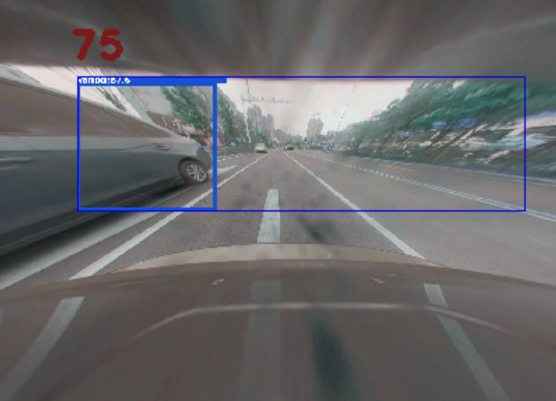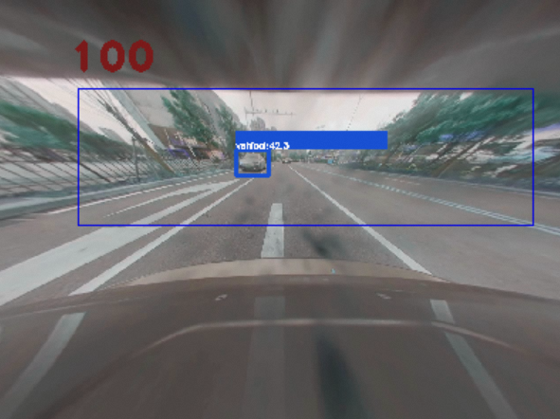

* mini data 3W矫正鱼眼+3W鱼眼 + 3WAR(实验6)：

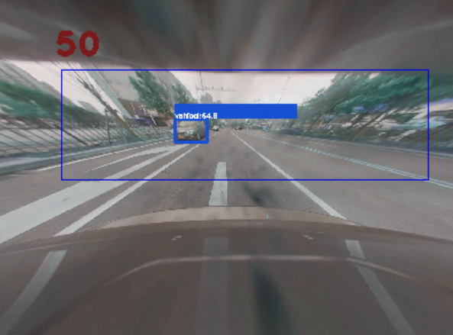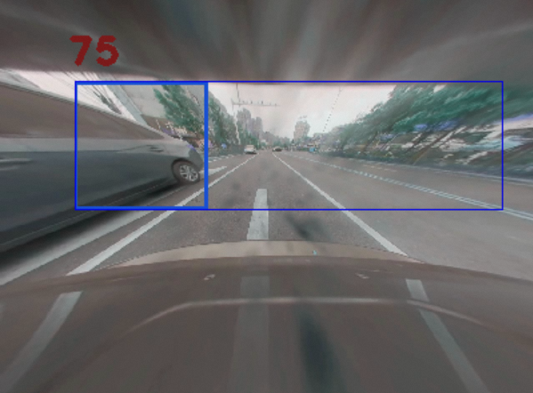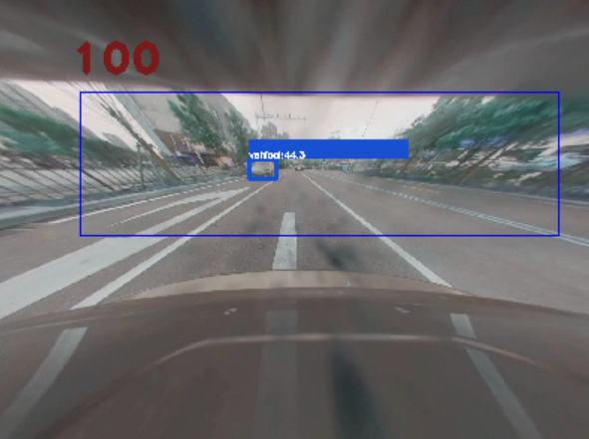

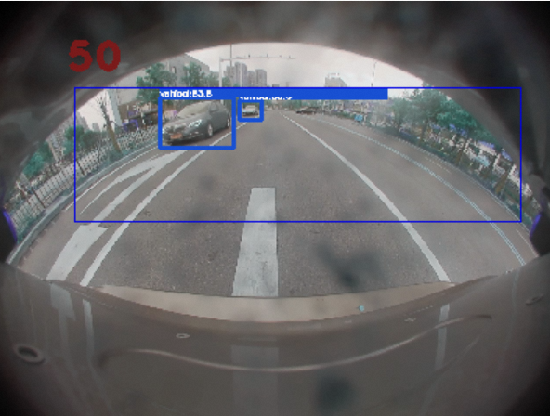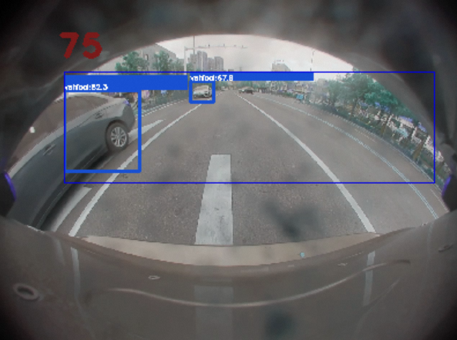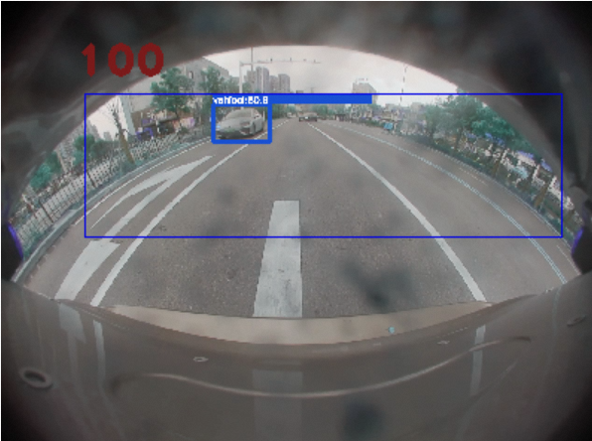

* Total data 8W矫正鱼眼+8W张鱼眼 + 10WAR(实验7)：

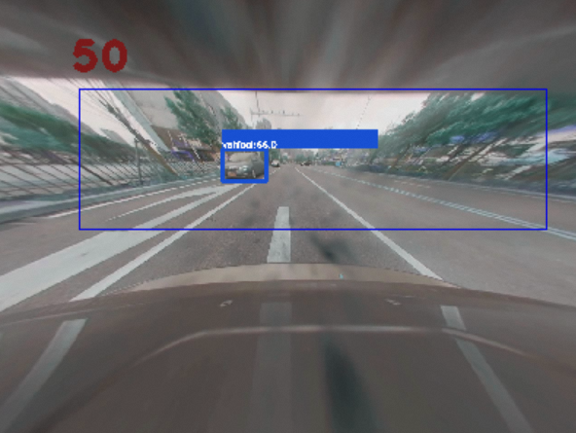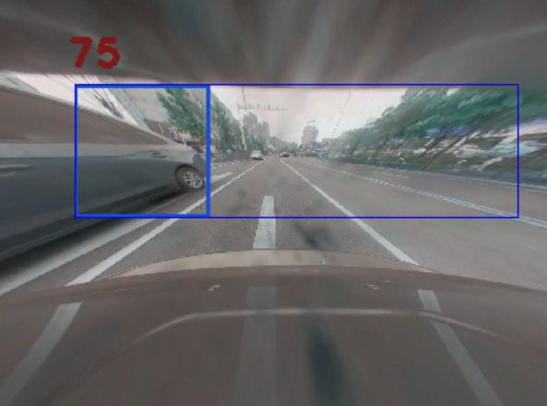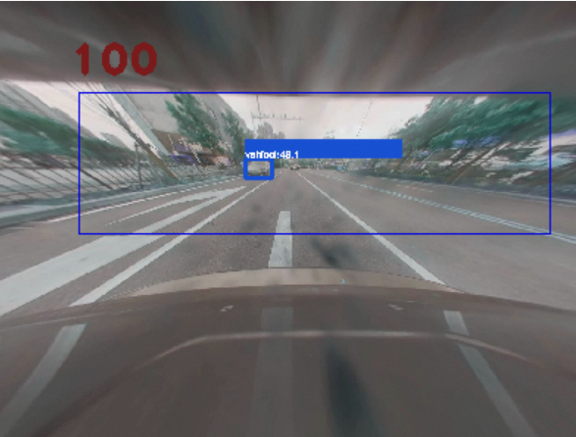

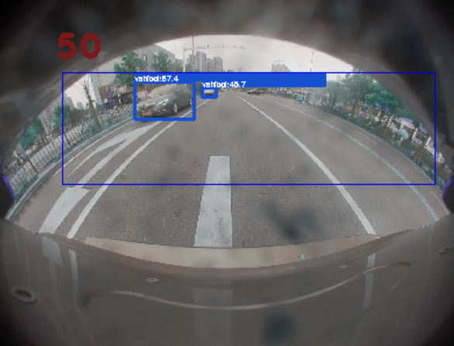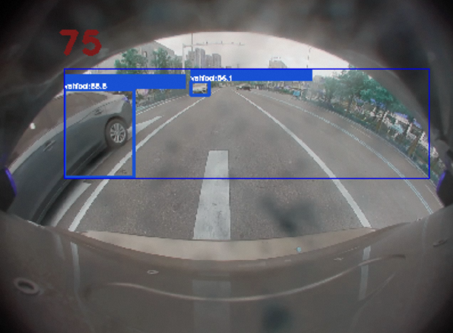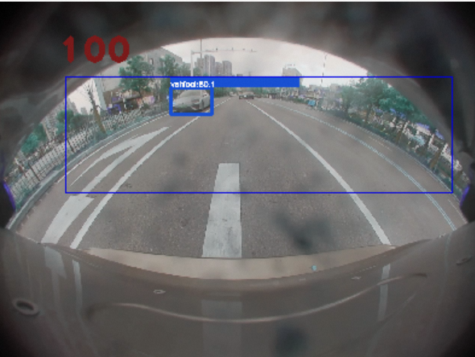

### - 鱼眼定性对比(ZSV_data)：

* mini data 圆柱矫正后的鱼眼3W(实验3)：

* Total data 8W矫正鱼眼+8W张鱼眼 + 10WAR(实验7)：

此处为语雀视频卡片，点击链接查看：[ZSV_data_L_BSD_2022-11-16_13_57_21.966.avi](https://aliyuque.antfin.com/uwk7mr/lvhh2l/xl9ov6pck1gxckgv#oIr93)

此处为语雀视频卡片，点击链接查看：[ZSV_data_L_BSD_2022-11-16_13_57_21.966.avi](https://aliyuque.antfin.com/uwk7mr/lvhh2l/xl9ov6pck1gxckgv#vjw6e)

此处为语雀视频卡片，点击链接查看：[ZSV_data_L_BSD_2022-11-16_14_08_32.153.avi](https://aliyuque.antfin.com/uwk7mr/lvhh2l/xl9ov6pck1gxckgv#k1H3k)

此处为语雀视频卡片，点击链接查看：[ZSV_data_L_BSD_2022-11-16_14_08_32.153.avi](https://aliyuque.antfin.com/uwk7mr/lvhh2l/xl9ov6pck1gxckgv#nrBiC)

### - AR定性对比：

* Total data 10WAR tevs multi task model(实验1)

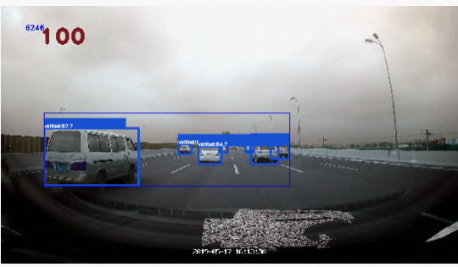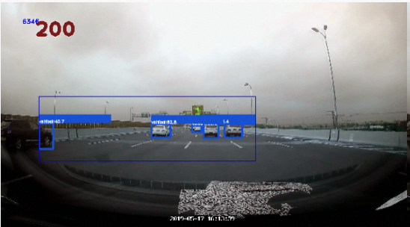

* mini data 3W鱼眼+3WAR(实验4)

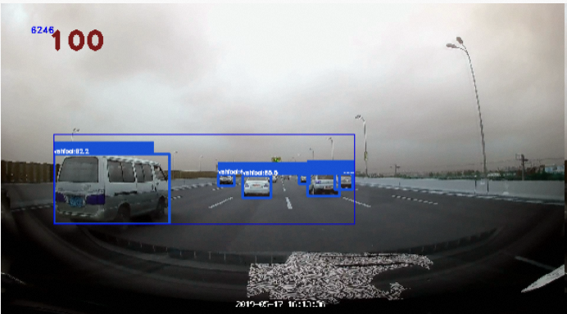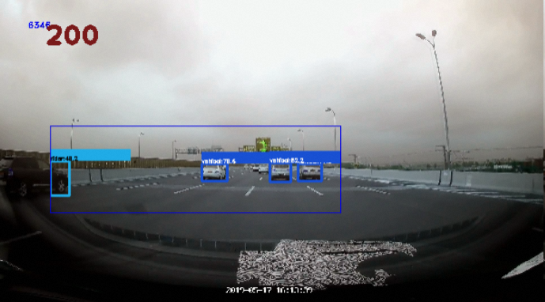

* mini data 3W矫正鱼眼+3WAR(实验5)

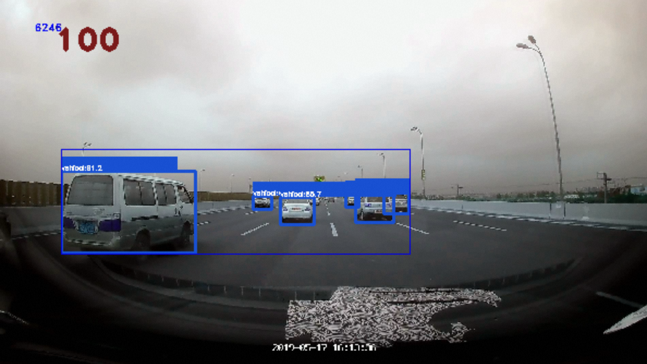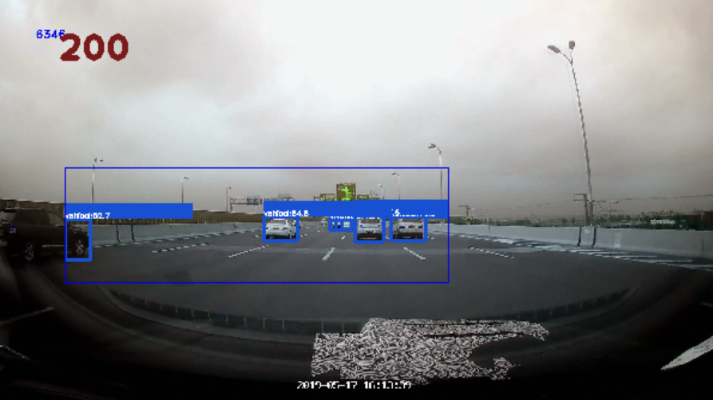

* mini data 3W矫正鱼眼+3W鱼眼 + 3WAR(实验6)

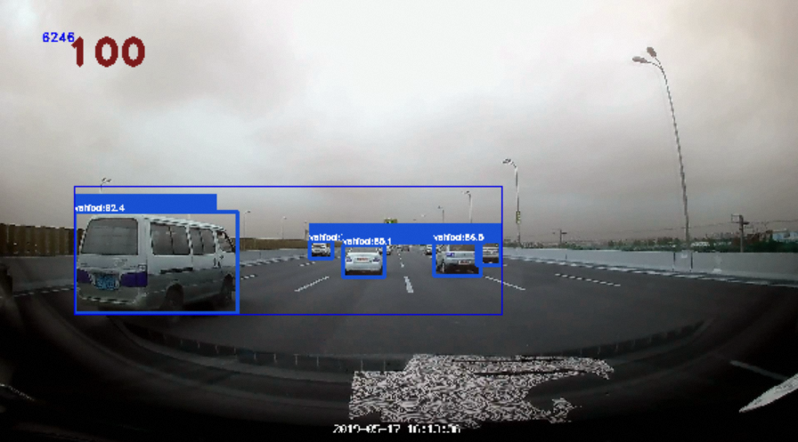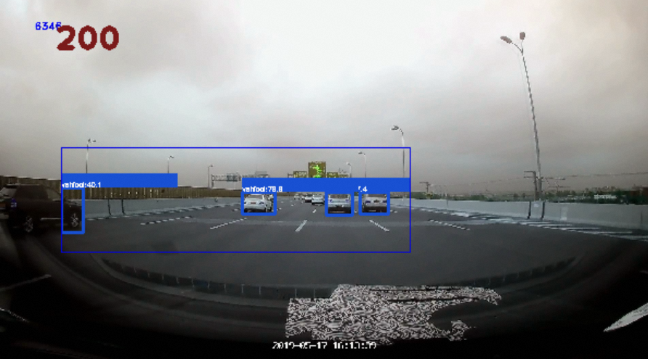

* Total data 8W矫正鱼眼+8W张鱼眼 + 10WAR(实验7)

